Module -1 LAB EXERCISE
1.Write a simple "Hello World" program in two different programming languages of your choice. Compare the structure and syntax.
C
#include <stdio.h>
int main() {

printf("Hello, World!\\n");
}

Python
print("Hello, World!")

2.Research and create a diagram of how data is transmitted from a client to a server over the internet.
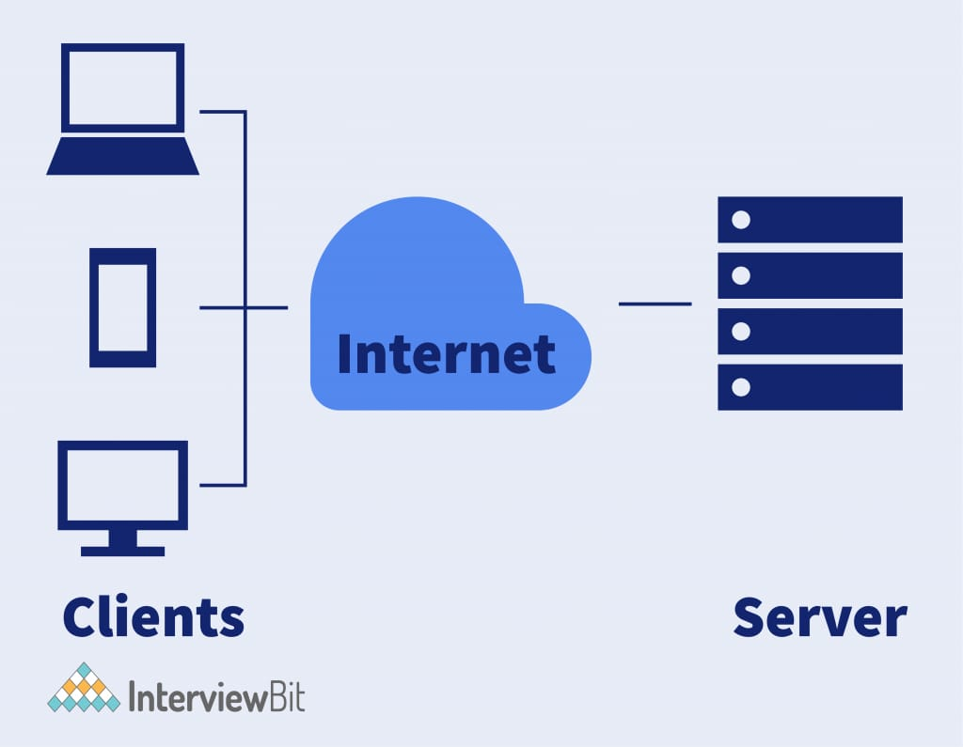

3.Design a simple HTTP client-server communication in any language.

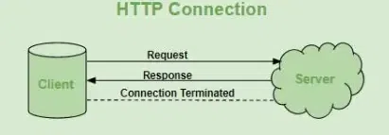

5. Simulate HTTP and FTP requests using command line tools (e.g., curl).
Ans: curl is a versatile command-line tool for transferring data with URL syntax, supporting various protocols including HTTP.
1. Basic GET Request:
To retrieve the content of a webpage:
Code
curl http://example.com

8.Design a basic three-tiersoftware architecture diagram for a web application.

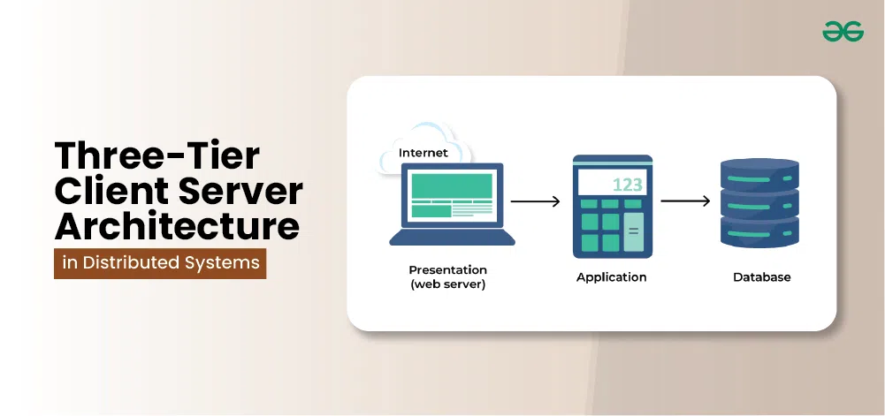

9.Create a case study on the functionality of the presentation, business logic, and data access layers of a given software system.
Ans:UI: Patient selects doctor and date.
Business Layer: Checks availability, applies rules.
Data Layer: Saves appointment data to DB.
10. Explore different types of software environments (development, testing, production). Set up a basic environment in a virtual machine.
1. Development Environment
For coding and initial testing.
Includes code editor, local server, etc.
2. Testing Environment
For QA/testing team to test features.
Similar to production but isolated.
3. Production Environment
Live version for real users.
Must be stable and secure.
Steps:
1. Install a VM tool (e.g., VirtualBox).
2. Set up an OS (e.g., Ubuntu).
3. Install development tools (VS Code, Node.js, MySQL, etc.).
4. Use separate folders or VMs for dev/test/prod.

11.Write and upload your firstsource code file to Github.

1. Go to \[github.com](https://github.com) and log in.
2. Click “New Repository” → Name it (e.g., first-code) → Click “Create repository”.
3. Click “Add file” → “Upload files”.
4. Choose your hello.py file and click “Commit changes”.
12. Create a Github repository and document how to commit and push code changes.

1. Create GitHub Repository
- Go to GitHub → New repository → enter name → Create.

2. Clone Locally
git clone https://github.com/<username>/<repo>.git
cd <repo>

3. Add & Commit Changes
# Add files
git add .

# Commit changes
git commit -m "Your message"

4. Push to GitHub
git push origin main
Replace main with master if needed.

13. Create a student account on Github and collaborate on a small project with a classmate
1. Create GitHub Account
Visit \[https://github.com](https://github.com)
Sign up using your email
Verify and log in

2.Apply for GitHub Student Pack (Optional)
Go to \[https://education.github.com/pack](https://education.github.com/pack)
Apply using your school/college email or ID proof

3.Create a Repository
Click on New repository → Name it → Choose public/private → Create

4. Collaborate
Go to repo → Settings → Collaborators → Add classmate’s GitHub username
They will receive an invite
5.Start Working Together
Both can clone, edit, commit, and push code
Use git pull to sync updates

14. Create a list of software you use regularly and classify them into the following categories: system, application, and utility software.

System Software

Windows 10/11 – Operating System
macOS – Operating System
Linux (Ubuntu) – Operating System
Device Drivers – Printer, Graphics, etc.

🔹 Application Software
MS Word / Excel / PowerPoint – Office work
Google Chrome / Firefox – Web browsing
WhatsApp / Zoom – Communication
Photoshop / Canva – Designing
VLC Media Player – Media playback

🔹 Utility Software
WinRAR / 7-Zip – File compression
Antivirus (e.g., Avast, Quick Heal) – Security
CCleaner – System cleaning
Disk Defragmenter – Optimize storage

15.Follow a GIT tutorial to practice cloning, branching, and merging repositories.
1. Clone a repository
git clone <repository-url>
2. Create a new branch
git checkout -b new-branch
3. Make changes, then stage and commit
git add .
git commit -m "your message"
4. Switch back to main branch
git checkout main
5. Merge the new branch into main
git merge new-branch
6. Push changes to remote
git push origin main

16.Write a report on the various types of application software and how they improve productivity.

1. MS Word – Writing, editing documents
2. MS Excel – Data entry, calculations
3. PowerPoint – Presentations
4. Gmail / Zoom – Communication
5. Photoshop – Graphic designing
6. MySQL – Database management

17.Create a flowchart representing the Software Development Life Cycle (SDLC)

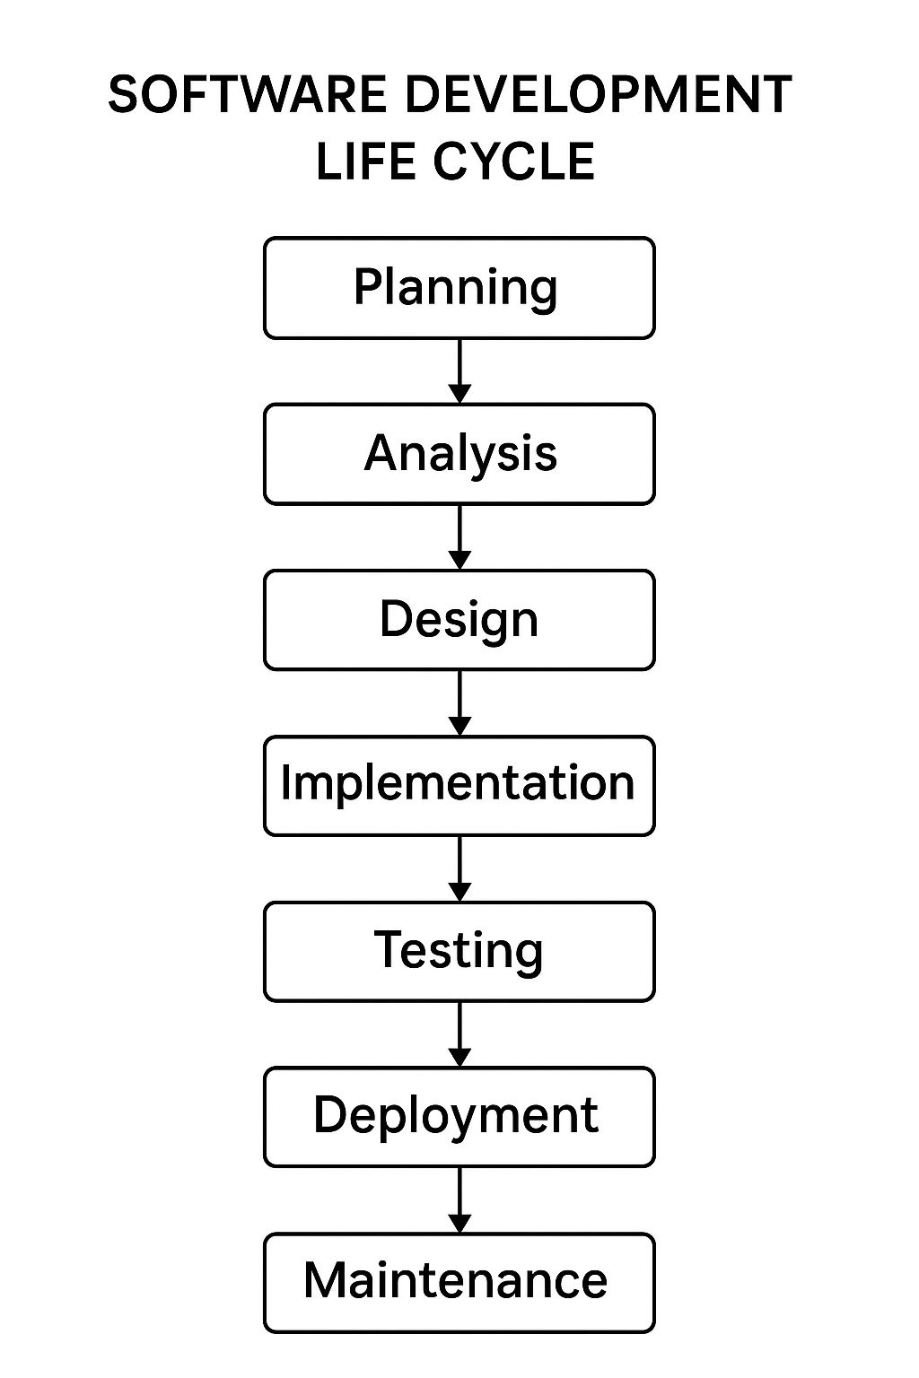

18.Write a requirement specification for a simple library managementsystem
Ans:Users: Admin, Librarian, Student
- Features:
- Add/Edit/Delete books
- Issue/Return books
- Search books
- User login
- Fine calculation
- Non-Functional:
- Secure, Fast, User-friendly
- Tech Used: HTML, PHP/Python, MySQL

19. Perform a functional analysis for an online shopping system.
Ans: 1. User Functions:
- Register/Login
- Browse products
- Search/filter products
- Add to cart
- Place orders
- Track orders
- Payment processing

2. Admin Functions:
- Manage product listings (Add/Edit/Delete)
- Manage user accounts
- View orders
- Generate reports

3. System Functions:
- Authentication & Authorization
- Inventory management
- Order processing
- Email/SMS notifications

20.Design a basic system architecture for a food delivery app
Ans:1. Presentation Layer (Frontend):
- Mobile App / Web Interface
- User login/signup
- Restaurant browsing
- Menu viewing
- Cart and checkout
- Order tracking

2. Application Layer (Backend / Business Logic):
- User Management
- Restaurant & Menu Management
- Order Management
- Payment Gateway Integration
- Delivery Management
- Notification System (Email/SMS/Push)

3. Data Access Layer (Database):
- Users Table
- Restaurants Table
- Menu Items
- Orders
- Payments
- Delivery Personnel

4. Third-Party Integrations:
- Maps API (e.g., Google Maps)
- Payment Gateway (e.g., Razorpay, Paytm)
- Messaging Services (e.g., Twilio for SMS)

21.Develop test cases for a simple calculator program.
#include <stdio.h>
int main()
{
float num1, num2, result;
char op;

printf("Enter first number: ");
scanf("%f", &num1);

printf("Enter operator (+ or -): ");
scanf(" %c", &op); // space before %c to ignore newline

printf("Enter second number: ");
scanf("%f", &num2);

if(op == '+')
result = num1 + num2;
else if(op == '-')
result = num1 - num2;
else {
printf("Invalid operator\n");
return 0;
}
printf("Result: %.2f\n", result);
return 0;
}
23.Create a DFD for a hospital management system.

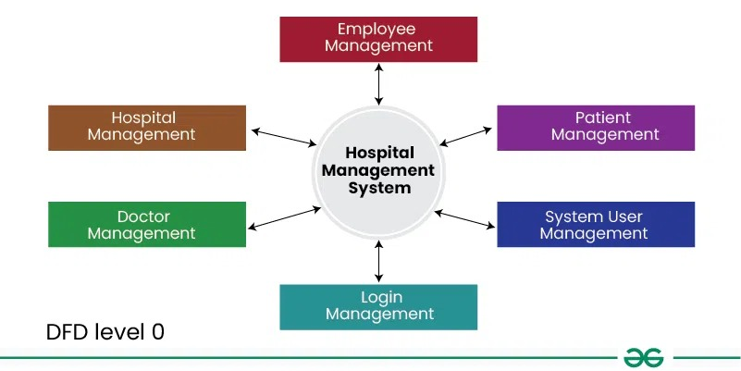

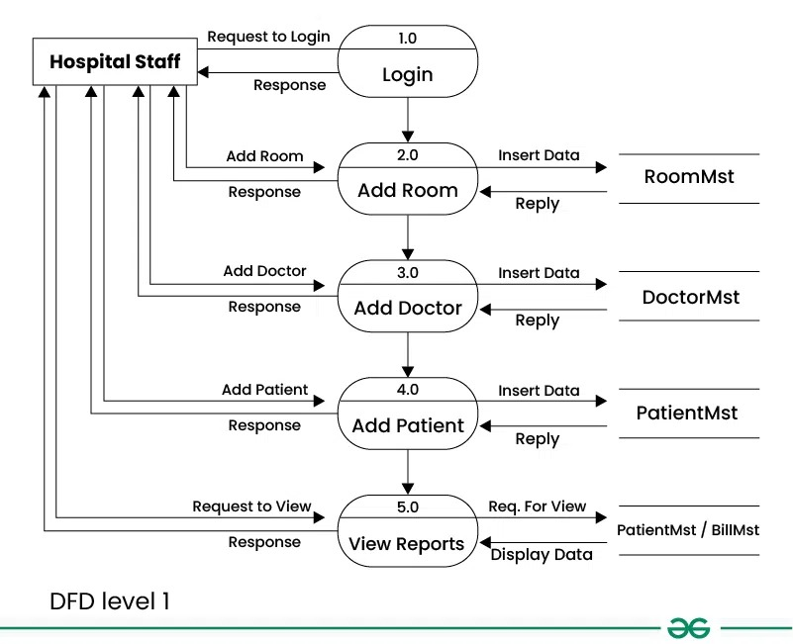

24.Build a simple desktop calculator application using a GUI library.
import tkinter as tk

def press(key):
entry_var.set(entry_var.get() + str(key))

def clear():
entry_var.set("")

def calculate():
try:
result = eval(entry_var.get())
entry_var.set(str(result))
except:
entry_var.set("Error")

# Main window
root = tk.Tk()
root.title("Simple Calculator")

entry_var = tk.StringVar()
entry = tk.Entry(root, textvariable=entry_var, width=16, font=('Arial', 24), bd=4, relief='ridge')
entry.grid(row=0, column=0, columnspan=4)

# Buttons
buttons = [
'7','8','9','+',
'4','5','6','-',
'1','2','3','C',
'0','=',''
]

row_val = 1
col_val = 0

for button in buttons:
if button != '':
action = lambda x=button: press(x) if x not in ['=','C'] else calculate() if x=='=' else clear()
tk.Button(root, text=button, width=5, height=2, font=('Arial',18), command=action)\
.grid(row=row_val, column=col_val, padx=3, pady=3)
col_val += 1
if col_val > 3:
col_val = 0
row_val += 1

root.mainloop()

25.Draw a flowchart representing the logic of a basic online registration system.

